SOFTWARE DESIGN DOCUMENT
for
Team Seaways

1.0
14.12.2025

Prepared by
Yavuz Selman Haltaş,
Ünal Sarıemir
Yusuf Alperen Dönmez
Emre Can Tuncer
Alperen Özdelen

TABLE OF CONTENTS
1 Introduction 3
1.1 Purpose of the system 3
1.2 Design goals 3
1.3 Definitions, acronyms, and abbreviations 3
1.4 References 3
1.5 Overview 3
2 Current software architecture 3
3 Proposed software architecture 3
3.1 Overview 3
3.2 Subsystem decomposition 3
3.3 Hardware/software mapping 3
3.4 Persistent data management 4
3.5 Access control and security 4
3.6 Global software control 4
3.7 Boundary conditions 4
4 Subsystem services 4
5 Glossary of Terms 4
6 Traceability 4

Introduction
This Software Design Document (SDD) describes the architecture and design of the Smart Personal Task Manager system. It provides a comprehensive view of the system's design, including the decomposition of the system into subsystems, the hardware/software mapping, data management, and the rationale behind major design decisions. This document serves as a blueprint for the implementation phase and as a reference for future maintenance and enhancement of the system.

Purpose of the system
The Smart Personal Task Manager is a web application designed to transform traditional to-do lists into a dynamic task management system based on the Franklin Covey methodology. The system enables users to manage tasks with advanced features including priority categorization (A/B/C/D), context tagging, recurring task automation, and visual timeline management through multiple calendar views. The application aims to elevate personal and professional productivity by providing intelligent task organization, timely reminders, and comprehensive project management capabilities.

Design goals
The following design goals guide the architecture and design decisions:
- Modularity: Decompose the system into loosely-coupled, highly-cohesive subsystems that can be developed, tested, and maintained independently.
- Extensibility: Design for future enhancements such as mobile applications, additional notification channels, and third-party integrations without major architectural changes.
- Performance: Ensure responsive user experience with page loads under 3 seconds and API response times under 2 seconds for typical operations.
- Scalability: Support at least 50 concurrent users without performance degradation through efficient database design and caching strategies.
- Security: Implement robust authentication using JWT tokens, password hashing with BCrypt, and protection against common web vulnerabilities.
- Maintainability: Apply design patterns (Strategy, Observer, Factory, Repository) to promote clean code architecture and facilitate future maintenance.
- Usability: Provide an intuitive user interface requiring minimal training for basic task operations.

Definitions, acronyms, and abbreviations
Term | Definition
API | Application Programming Interface
DTO | Data Transfer Object - objects that carry data between processes
JPA | Java Persistence API - specification for ORM in Java
JWT | JSON Web Token - compact token format for authentication
ORM | Object-Relational Mapping
REST | Representational State Transfer - architectural style for APIs
SPA | Single Page Application
STOMP | Simple Text Oriented Messaging Protocol - messaging protocol for WebSocket
CRUD | Create, Read, Update, Delete - fundamental database operations

References
- CSE443 Requirements Analysis Document (RAD) - Team Seaways, Version 1.0
- Object-Oriented Software Engineering, Using UML, Patterns, and Java, 3rd Edition, by Bernd Bruegge and Allen H. Dutoit
- Spring Boot Documentation: https://spring.io/projects/spring-boot
- React.js Documentation: https://react.dev/
- PostgreSQL Documentation: https://www.postgresql.org/docs/
- Franklin Covey - Manage Your Time and Energy Effectively

Overview
This document is organized into six main sections. Section 2 describes the current software architecture landscape and existing solutions. Section 3 presents the proposed software architecture including subsystem decomposition, hardware/software mapping, data management, access control, global software control, and boundary conditions. Section 4 details the services provided by each subsystem. Section 5 provides a glossary of terms, and Section 6 establishes traceability between design elements and requirements.

Current software architecture
Currently, users manage personal and professional tasks through various fragmented approaches that lack integration and intelligent features. This section surveys the existing architectures and their limitations that the Smart Personal Task Manager addresses.
Existing Methods:
1. Physical Planners and Notebooks:
- Manual task writing with basic to-do lists
- No automated reminders or recurring task support
- Risk of loss with no backup mechanism
2. Basic Digital To-Do Lists (Apple Reminders, Google Keep, Todoist):
- Limited organizational structure beyond basic lists
- Minimal priority categorization
- Weak context-based filtering
3. Spreadsheet-based Solutions:
- Manual entry and updating required
- No automated notifications
- Difficult to visualize timelines
Key Problems Addressed by the New System:
- Lack of integration - task information scattered across multiple tools
- No intelligent scheduling - recurring tasks require manual recreation
- Poor visualization - difficult to see task distribution across time periods
- Inconsistent prioritization - no standardized priority framework
- Missing notifications - users must remember to check tasks regularly
- No project hierarchy - tasks cannot be grouped under larger projects
- Accessibility issues - data not accessible across devices seamlessly
- 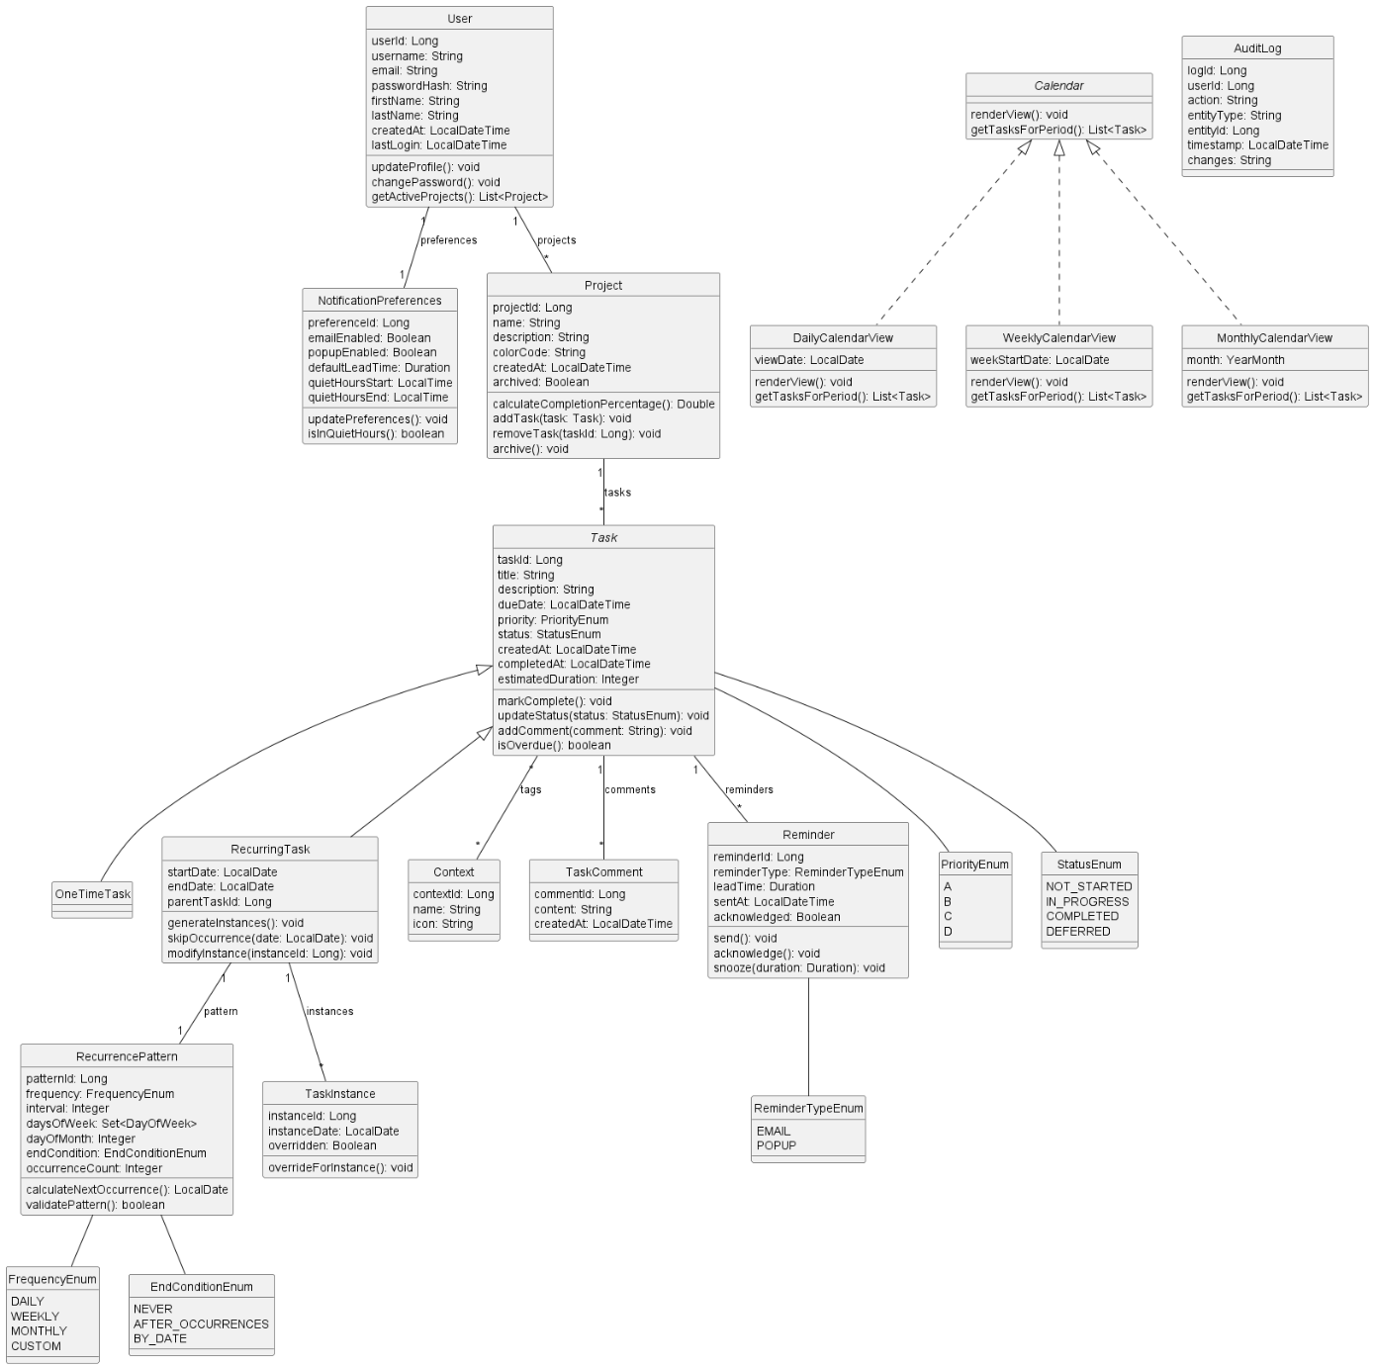

Proposed software architecture
The third section documents the system design model of the new system.

Overview
The Smart Personal Task Manager follows a three-tier architecture with clear separation between the Presentation Layer (React frontend), Business Logic Layer (Spring Boot backend), and Data Layer (PostgreSQL database). The system is designed as a RESTful web application with real-time capabilities through WebSocket connections.
High-Level Architecture:
- Frontend (Presentation Layer): React 18 with TypeScript, Vite build tool, Tailwind CSS, TanStack Query for data fetching, Zustand for state management
- Backend (Business Logic Layer): Spring Boot 3.2 RESTful API with layered architecture (Controller → Service → Repository)
- Database (Data Layer): PostgreSQL 15 for persistent data storage
- Authentication: JWT-based security with 24-hour token expiration
- Real-time Communication: WebSocket with STOMP protocol for notifications
Design Patterns Applied:
- Strategy Pattern: Calendar view rendering with interchangeable Daily, Weekly, and Monthly strategies
- Observer Pattern: Notification system with Email and Popup notification observers
- Factory Pattern: TaskFactory for creating OneTimeTask and RecurringTask instances
- Repository Pattern: Data access layer abstraction using Spring Data JPA repositories

Subsystem decomposition
The system is decomposed into the following subsystems, each with clearly defined responsibilities:
Subsystem | Responsibilities
Authentication Subsystem | User registration, login, logout, password management, JWT token generation and validation, session management
User Management Subsystem | Profile management, notification preferences, user settings
Project Management Subsystem | Project CRUD operations, project archiving, completion percentage calculation, task-project associations
Task Management Subsystem | OneTimeTask and RecurringTask creation via Factory pattern, task CRUD, status transitions, context tag management, task instance generation for recurring tasks
Calendar Subsystem | Calendar view rendering using Strategy pattern (DailyCalendarView, WeeklyCalendarView, MonthlyCalendarView), task scheduling visualization, navigation
Notification Subsystem | Reminder scheduling, notification triggering using Observer pattern (EmailNotificationObserver, PopupNotificationObserver), WebSocket real-time notifications
Search & Filter Subsystem | Task searching by keywords, filtering by priority/status/context/project/date, sorting capabilities, real-time filter updates
Audit Subsystem | Logging all task modifications with user and timestamp, audit trail maintenance for traceability

Backend Package Structure:
- com.taskmanager.controller - REST API controllers (AuthController, TaskController, ProjectController, CalendarController, etc.)
- com.taskmanager.service - Business logic services (UserService, TaskService, CalendarService, NotificationService, etc.)
- com.taskmanager.repository - JPA repositories for data access
- com.taskmanager.entity - JPA entities (User, Project, Task, OneTimeTask, RecurringTask, etc.)
- com.taskmanager.dto - Data Transfer Objects
- com.taskmanager.strategy - Calendar view strategies (CalendarViewStrategy interface, DailyCalendarView, WeeklyCalendarView, MonthlyCalendarView)
- com.taskmanager.observer - Notification observers (NotificationObserver interface, EmailNotificationObserver, PopupNotificationObserver)
- com.taskmanager.factory - TaskFactory for task creation
- com.taskmanager.config - Configuration classes (SecurityConfig, WebSocketConfig, OpenApiConfig)
com.taskmanager.security - JWT service and authentication filter

Hardware/software mapping
The system is designed to run in a containerized environment using Docker, with the following deployment architecture:
Component | Technology | Deployment
Frontend | React 18, TypeScript, Nginx | Docker container serving static files via Nginx on port 80
Backend API | Java 17, Spring Boot 3.2 | Docker container running executable JAR on port 8080
Database | PostgreSQL 15 | Docker container with persistent volume on port 5432
Client Browser | Chrome, Firefox, Safari, Edge | User's device - desktop or mobile

Container Orchestration:
Docker Compose is used to orchestrate all containers with a dedicated bridge network (taskmanager-network) enabling service discovery. Health checks ensure dependent services start in correct order: PostgreSQL → Backend → Frontend.
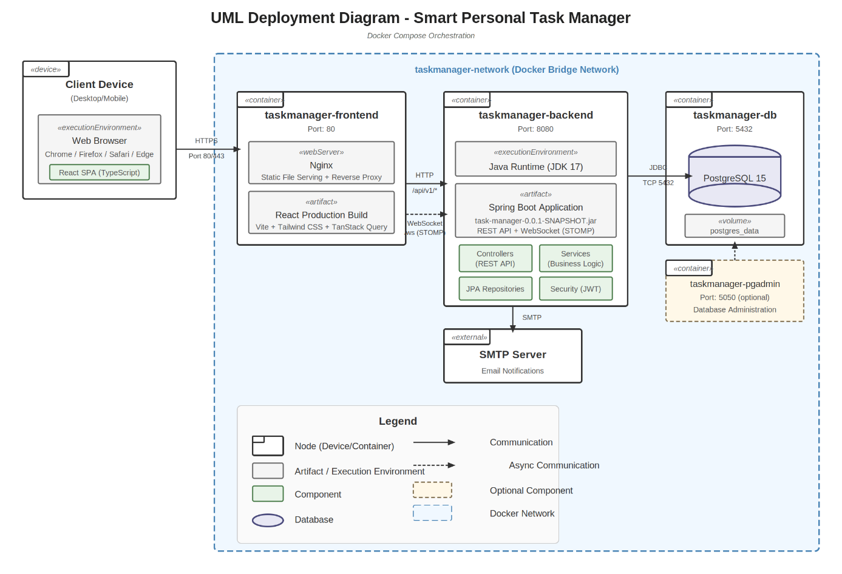

Persistent data management
The system uses PostgreSQL 15 as the relational database with Spring Data JPA (Hibernate) as the ORM layer. The database schema is managed using JPA's auto-update feature during development and migration scripts for production.
Core Entity Relationships:
- User (1) → (*) Project: One user owns many projects
- Project (1) → (*) Task: One project contains many tasks
- Task (*) → (*) Context: Many-to-many for flexible context tagging
- RecurringTask (1) → (*) TaskInstance: One recurring task generates many instances
- Task (1) → (*) Reminder: One task can have multiple reminders
- Task (1) → (*) TaskComment: One task can have multiple comments
- User (1) → (1) NotificationPreferences: One-to-one for user notification settings
Inheritance Strategy:
The Task entity uses Single Table Inheritance (SINGLE_TABLE strategy) with a discriminator column (task_type) to distinguish between OneTimeTask and RecurringTask subclasses. This provides optimal query performance for polymorphic queries.
Database Tables:
- users - User accounts and credentials
- projects - Project definitions
- tasks - All tasks (one-time and recurring) with discriminator
- recurrence_patterns - Recurring task schedule patterns
- task_instances - Individual occurrences of recurring tasks
- contexts - Context tags (@home, @work, etc.)
- task_contexts - Many-to-many join table
- reminders - Task reminders
- task_comments - Task comments and notes
- notification_preferences - User notification settings
- audit_logs - System audit trail

Access control and security
The system implements a comprehensive security model using Spring Security with JWT-based authentication.
Authentication Mechanism:
- Users authenticate via email/password credentials
- Passwords are hashed using BCrypt algorithm before storage
- Successful authentication returns a JWT token (24-hour expiration)
- JWT tokens are validated on each API request via JwtAuthenticationFilter
- Token refresh mechanism for extended sessions
Authorization Model:
The system uses a simple role-based access control with a single USER role. All authenticated users have full access to their own data. Resource-level authorization ensures users can only access their own projects, tasks, and settings. The service layer validates ownership before any data modification.
Security Measures:
- CORS configuration to allow frontend origin
- HTTPS enforcement in production
- Input validation using Jakarta Bean Validation
- SQL injection prevention via parameterized queries (JPA)
- XSS prevention through React's built-in escaping

Global software control
The system employs a request-response model for most operations, with event-driven architecture for real-time notifications.
Request Flow:
- Client sends HTTP request to REST API endpoint
- JwtAuthenticationFilter validates the token
- Controller receives and validates request
- Service layer executes business logic
- Repository layer performs database operations
- Response returned with appropriate HTTP status code
Real-Time Notifications:
WebSocket connections using STOMP protocol provide real-time updates. The NotificationSubject (Observable) maintains a list of NotificationObservers (EmailNotificationObserver, PopupNotificationObserver) and notifies them when reminders are triggered or tasks become overdue.
Background Processing:
- Scheduled tasks using Spring's @Scheduled annotation
- Daily reminder check at configurable time
- Recurring task instance generation
- Overdue task notification processing

Boundary conditions
System Startup:
- Docker Compose initiates PostgreSQL container first
- Health check verifies database is ready
- Backend container starts and connects to database
- JPA auto-update applies any schema changes
- Default context tags are seeded if not present
- Backend health check endpoint becomes available
- Frontend container starts serving static files
System Shutdown:
- Graceful shutdown signal sent to containers
- Active HTTP requests are completed
- WebSocket connections are closed
- Database connections are properly closed
- Persistent data in PostgreSQL volume is preserved
Error Handling:
- GlobalExceptionHandler provides centralized exception handling
- ResourceNotFoundException for missing entities (HTTP 404)
- ValidationException for invalid inputs (HTTP 400)
- Database connection failures trigger automatic retry
- Transaction rollback for failed operations ensures data integrity
- Structured logging with SLF4J for debugging

Subsystem services
4.1 Authentication Subsystem
AuthController Operations:
- POST /api/v1/auth/register - Register new user account
- POST /api/v1/auth/login - Authenticate user and return JWT token
- POST /api/v1/auth/refresh - Refresh JWT token
4.2 User Management Subsystem
UserController Operations:
- GET /api/v1/users/me - Get current user profile
- PUT /api/v1/users/me - Update user profile
- PUT /api/v1/users/me/password - Change password
- PUT /api/v1/users/me/notifications - Update notification preferences
4.3 Project Management Subsystem
ProjectController Operations:
- GET /api/v1/projects - List all user projects
- POST /api/v1/projects - Create new project
- GET /api/v1/projects/{id} - Get project details
- PUT /api/v1/projects/{id} - Update project
- DELETE /api/v1/projects/{id} - Delete project
- POST /api/v1/projects/{id}/archive - Archive project
4.4 Task Management Subsystem
TaskController Operations:
- GET /api/v1/tasks - Get all tasks with optional filtering
- POST /api/v1/tasks/one-time - Create one-time task via TaskFactory
- POST /api/v1/tasks/recurring - Create recurring task via TaskFactory
- GET /api/v1/tasks/{id} - Get task details
- PUT /api/v1/tasks/{id} - Update task
- DELETE /api/v1/tasks/{id} - Delete task
- POST /api/v1/tasks/{id}/complete - Mark task complete
- PUT /api/v1/tasks/{id}/status - Update task status
- GET /api/v1/tasks/today - Get today's tasks
- GET /api/v1/tasks/overdue - Get overdue tasks
4.5 Calendar Subsystem
CalendarController Operations (Strategy Pattern):
- GET /api/v1/calendar/daily?date={date} - Daily view using DailyCalendarView strategy
- GET /api/v1/calendar/weekly?date={date} - Weekly view using WeeklyCalendarView strategy
- GET /api/v1/calendar/monthly?date={date} - Monthly view using MonthlyCalendarView strategy
4.6 Notification Subsystem
NotificationController Operations (Observer Pattern):
- GET /api/v1/notifications - Get notification history
- POST /api/v1/notifications/{id}/acknowledge - Acknowledge notification
- POST /api/v1/notifications/{id}/snooze - Snooze notification
- WebSocket /ws - Real-time notification channel using STOMP
4.7 Context Subsystem
ContextController Operations:
- GET /api/v1/contexts - Get all context tags
POST /api/v1/contexts - Create custom context tag

Glossary of Terms
Term | Definition
Context Tag | Situational or environmental label applied to tasks indicating where or when task can be completed (@home, @work, @phone, @errands)
Franklin Covey Priority | Time management methodology using A (Critical), B (Important), C (Nice to have), D (Delegate/Defer) priority levels
One-Time Task | A task that occurs exactly once on a specified date
Recurring Task | A task that repeats on a defined schedule (daily, weekly, monthly), automatically generating multiple task instances
Task Instance | A single occurrence of a recurring task with a specific date
Recurrence Pattern | Schedule definition for recurring tasks including frequency, interval, and end condition
Strategy Pattern | Design pattern enabling selection of algorithm at runtime; used for calendar views
Observer Pattern | Design pattern where observers are notified of changes to subject; used for notifications
Factory Pattern | Design pattern for creating objects without specifying exact class; used for task creation
Lead Time | Advance notice period for reminders (e.g., 15 minutes, 1 hour, 1 day before due date)

Traceability
This section establishes traceability between the design elements described in this SDD and the requirements specified in the Requirements Analysis Document (RAD).
6.1 Design Elements to Requirements
Design Element | Supported Requirements
Authentication Subsystem | FR-1, FR-2, FR-3, FR-5, FR-6, NFR-34, NFR-49
User Entity | FR-1, FR-2, FR-3, FR-4, FR-5, FR-6
Project Entity & Service | FR-7, FR-8, FR-9, FR-10, FR-11, FR-12
Task Entity (Abstract) | FR-13, FR-16, FR-17, FR-18, FR-19, FR-20, FR-22, FR-23
OneTimeTask Entity | FR-13
RecurringTask Entity | FR-14, FR-15, FR-24, FR-25, NFR-21
TaskFactory (Factory Pattern) | FR-13, FR-14, NFR-36
CalendarViewStrategy (Strategy) | FR-26, FR-27, FR-28, FR-29, FR-30, FR-31, NFR-36
DailyCalendarView | FR-26, FR-30, NFR-17
WeeklyCalendarView | FR-27, FR-30, FR-31, FR-32, FR-33, NFR-17
MonthlyCalendarView | FR-28, FR-30, FR-35, NFR-17
NotificationObserver (Observer) | FR-36, FR-37, FR-39, NFR-36
EmailNotificationObserver | FR-36, FR-39, NFR-22
PopupNotificationObserver | FR-37, NFR-41
Context Entity | FR-21, FR-46
Reminder Entity | FR-36, FR-38, FR-40, FR-41, FR-42
AuditLog Entity | FR-60, NFR-14
JPA Repositories | FR-57, NFR-36 (Repository Pattern)
WebSocket Configuration | NFR-41
Docker Compose Deployment | NFR-43, NFR-44, NFR-45, NFR-46, NFR-47

6.2 Subsystems to Use Cases
Subsystem | Use Cases Supported
Authentication | UC-Register Account, UC-Login, UC-Reset Password
User Management | UC-Manage Profile, UC-Configure Notification Preferences
Project Management | UC-Create Project, UC-View Projects, UC-Update Project, UC-Delete Project, UC-Archive Project
Task Management | UC-1: Create Recurring Task, UC-Create One-Time Task, UC-View Tasks, UC-Update Task, UC-Complete Task, UC-Delete Task
Calendar | UC-2: View Weekly Calendar, UC-View Daily Calendar, UC-View Monthly Calendar, UC-Navigate Calendar
Notification | UC-3: Receive Email Notification, UC-Receive Popup Notification, UC-Snooze Notification, UC-View Notification History
Search & Filter | UC-4: Filter Tasks by Priority, UC-Search Tasks, UC-Filter by Status, UC-Filter by Context, UC-Sort Tasks
Audit | UC-5: Export Data, UC-View Audit Trail

